

**Czech students introduce their popcorn PopUpShow at Lodz Design Festival**

*03/10/2015, Zlín, Czech Republic*

**After successful introduction of PopUpShow at Ventura Lambrate (Milan Design Week) in April 2015, students bring their popcorn exhibition to new audience. Their PopUpShow reflects contemporary PopUpDesign and PopUpCulture trends in design. Visit them in October 8-18 at Lodz Design Festival, Poland.**

**About exhibition**

The PopUpShow presents recent student works from Tomas Bata University in Zlín focusing on wood as a conceptual topic as well as a basic material. The presentation itself reflects the well-known phenomenon of PopUpCulture, forming a PopUpShow with PopUpDesign and PopCorn.

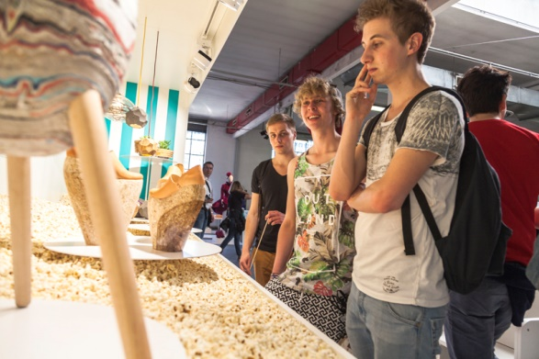

The transdiciplinary design team is led by **Michael Vasku** from Vasku&Klug studio based in Vienna, Austria, which ranges from architecture, interior design and exhibition architecture to scenography and corporate architecture. The co-operation between Michael Vasku and Tomas Bata University in Zlín has been proven on many projects, eg. About Layabouts (2014), Bite Me Milan (2013), Newintage (2012).

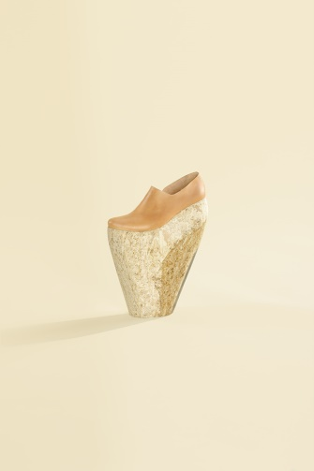

**About products**

There are thirteen products all together and they focus on combination of wood with other materials. Students have grasped the chance to create products with no limits. Various products such as flowerpot, coffee tables, interior lights, coffin, jewellery or wooden radiator have been created.

As for materials students combined wood with concrete, resin, glass, porcelain. They used CNC milling and also charred surfaces of wood.

Exhibitors: **Branislav Glejtek, Daniel Szöllösi, Eva Wirthová, Jiří Maxmilián Blšták, Karolína Fardová, Kateřina Brůhová, Lucia Kubišová, Lucia Plevová, Lucia Regásková, Lukáš Uliarczyk, Tereza Čižmárová, Uranbileg Altangerel, Veronika Zelezníková**.

All products are photographed by **Filip Beránek** who is studying advertising photography.

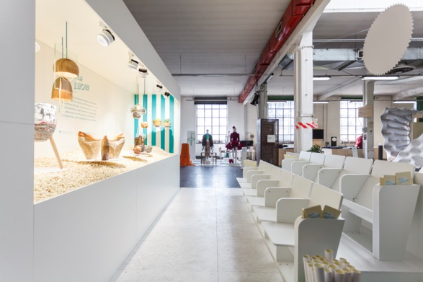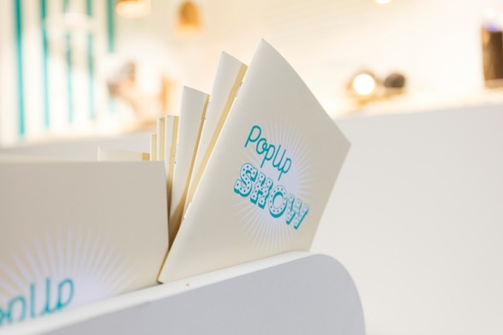**Detailed information about products and designers are available on** [**www.PopUpShow.cz**](http://www.PopUpShow.cz)**.**

**About installation and graphic design**

The PopUpShow Scene has been created by **Michael Chomiszak** who is studying Spatial Design. To evoke atmosphere of cinema he used the cinema composition – one part reminds the movie screen where most of products are placed, on the other are placed cinema seats for visitors who can sit and enjoy the PopUpShow. To emphasize the PopUpInspiration the products are flodded with PopCorn. Moreover, incoming visitors will get a cone of fresh PopCorn.

Graphic design of the scene is a great work of two students **Petr Belák** and **Veronika Holíková** who created the whole visual identity of the exhibition including the title typography.

**About Lodz Design Festival**

Lodz Design Festival is an international festival of design taking place since 2007 in Łódź, Poland. It is currently the most important event related to the design in Central and Eastern Europe. Festival is well known for its variety - from industrial design through art craft design, graphic design, architecture, design services, up to fashion.

**About Tomas Bata University in Zlín, Czech Republic**

Students are sparkling, young and full of creative ideas, just like their university they study at. They are used to working in cross-functional teams and regularly win prestigious international awards such as Cannes Young Lions, the Red Dot Award, Young Package, and the Swedish Innovation Prize.

Students study graphic design, spatial design, advertising photography, industrial design, marketing communications, audiovisual arts, shoe and fashion design and glass design at The Faculty of Multimedia, Tomas Bata University in Zlín, Czech Republic.

Tomas Bata University in Zlín regurarly present students work abroad, in the Milan Design Week presented PopUpSHow in 2015, About Layabouts in 2014, Bite Me Milan in 2013. They present also on othe design events, in October 2015 students present their work in Tokio Design Week called Pairs in Squares.

**Progress each year**

"*We are very pleased to present our students work at Milan Design Week for the third time. It is a kind of reflection for us that we do with students a great progress each year. For each of twenty students who are involved this year it means a very important experience in the cross-functional team and they test their work in the high profile international environment*," says **Richard Vodička**, Coordinator from Tomas Bata University in Zlín, Czech Republic.

**Press Contact**

Anežka Adamíková | +420 733 755 959 | info@popupshow.cz

[PopUpShow.cz](http://popupshow.cz/) | [Facebook.com/popupSHOWcz](http://www.facebook.com/popupSHOWcz/) 